Task – 1: Add a Lock to the resource group and test deletion
Step 1: Resource locks are used to prevent accidental deletions or modifications of any critical environment. Below, the screenshot shows that there is no lock currently applicable on the resource group named as “myRGLocks”.
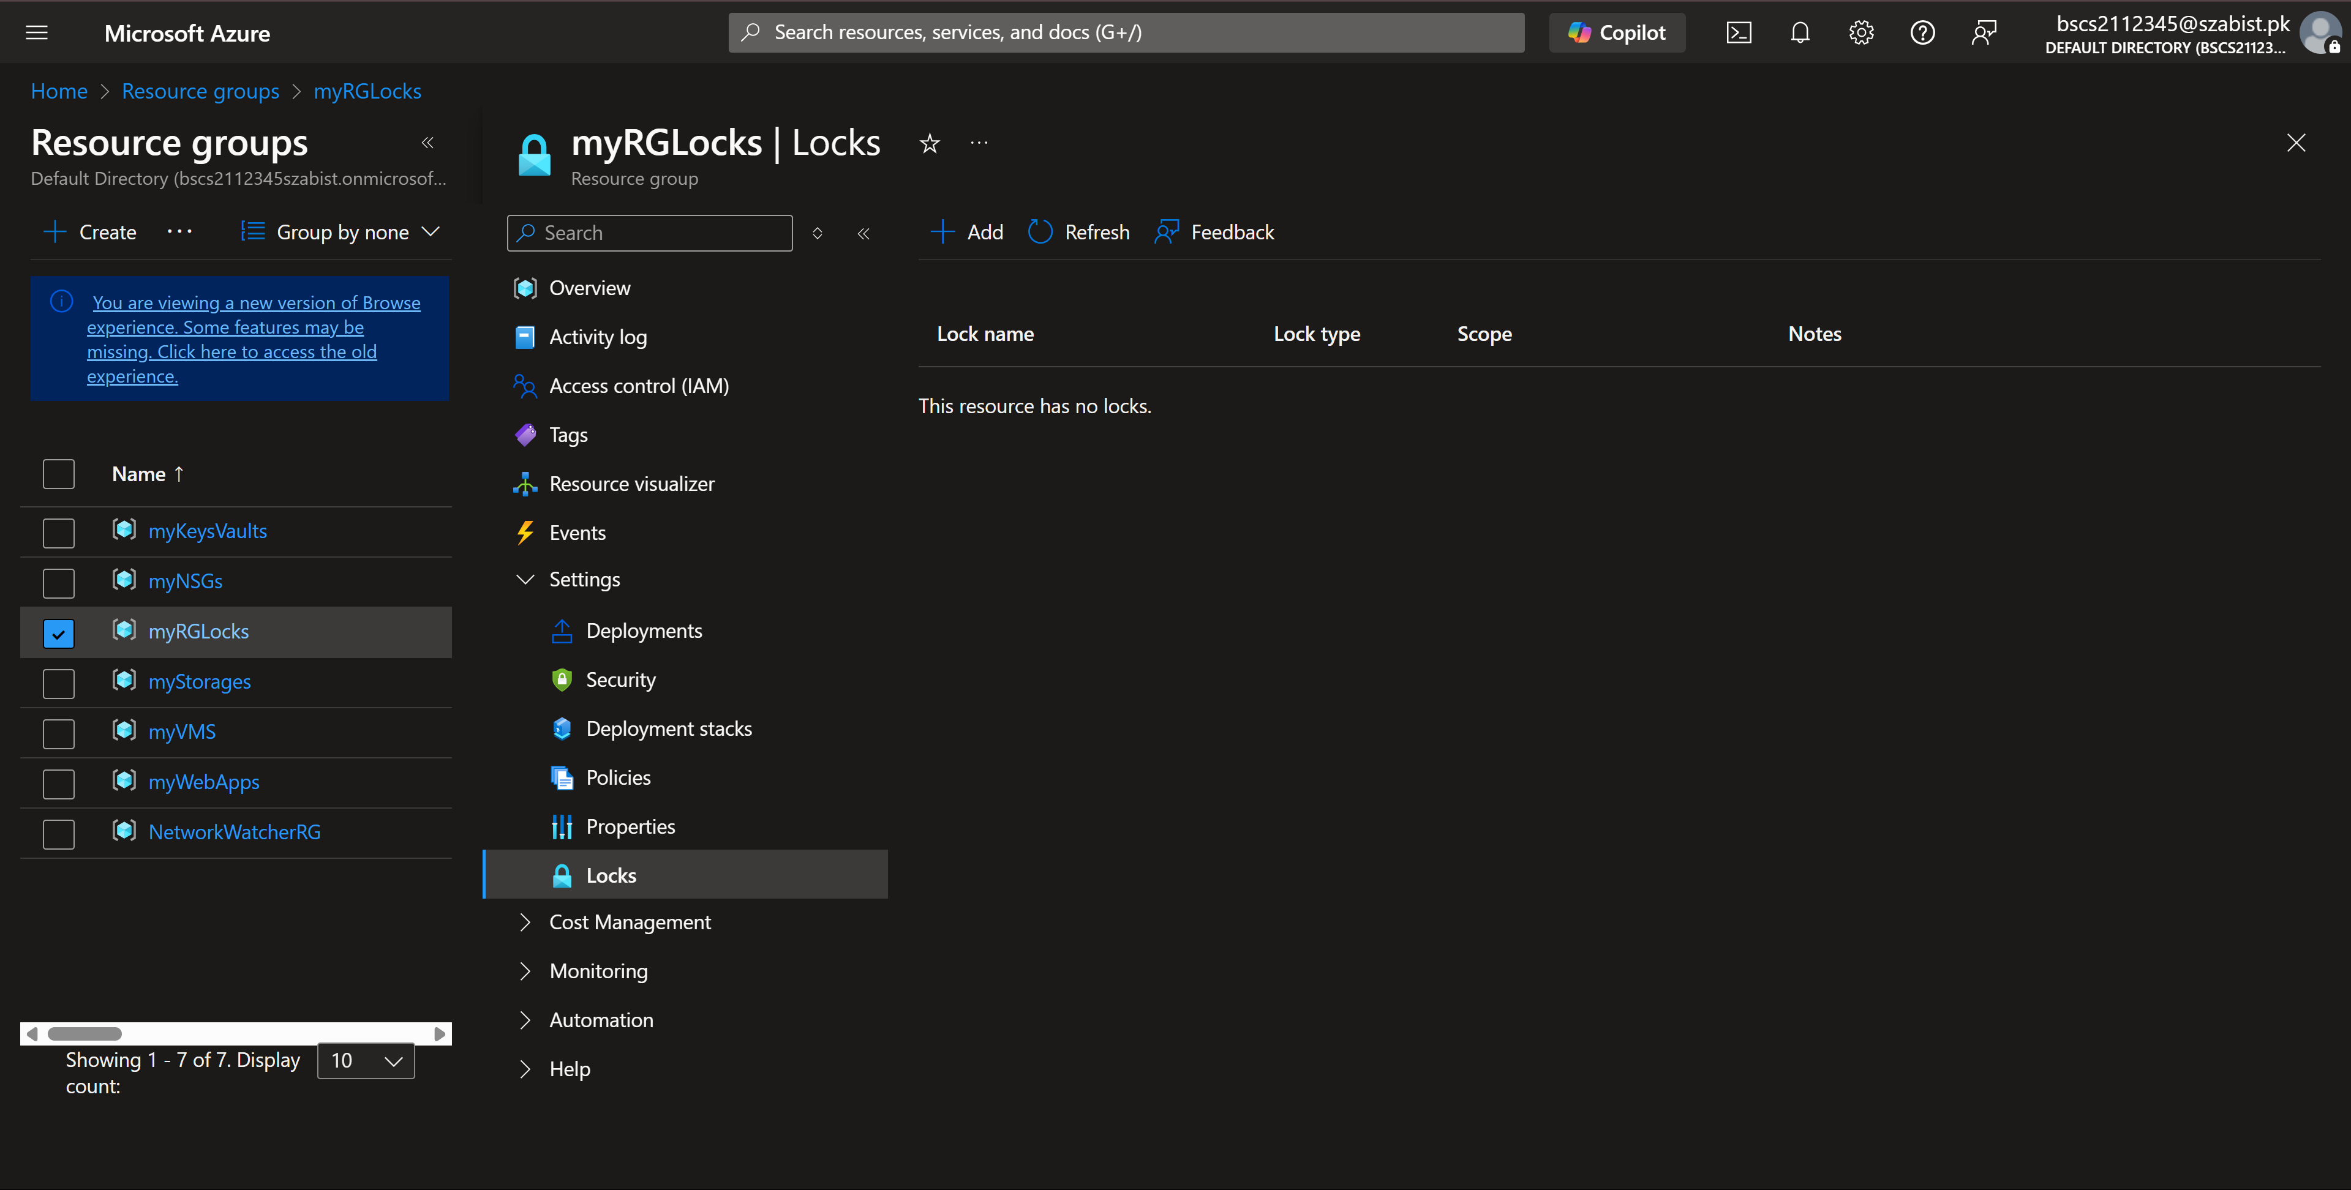
Step 2: To add a lock on delete, I clicked on “+ Add” and filled in the name and the type of the lock. By pressing “OK” the lock will be applied on the resource group.
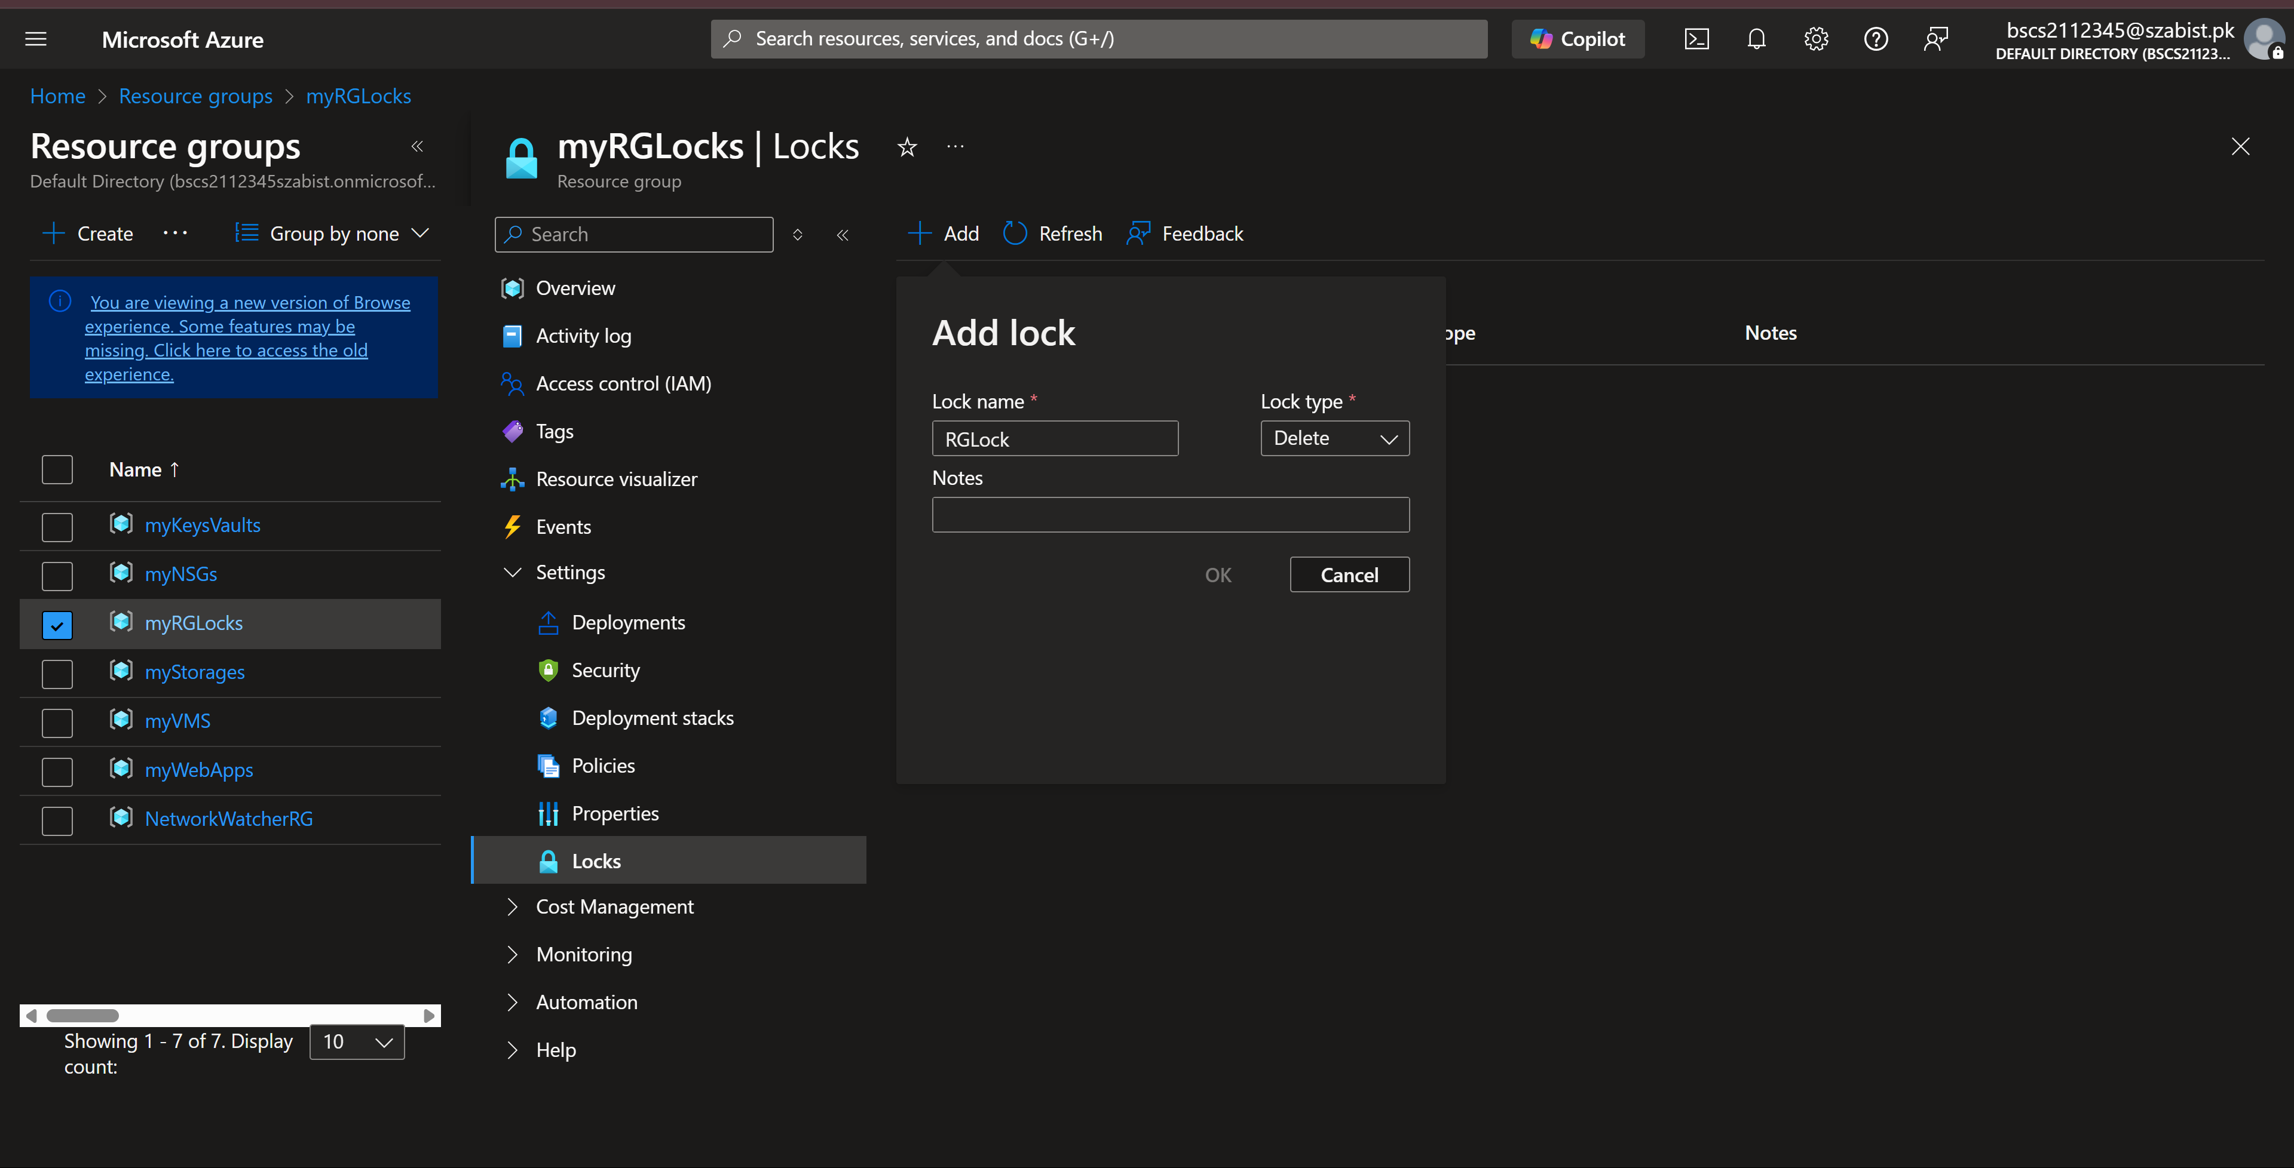

Step 3: Now when I try to delete the resource group, azure prompts with the error stating the resource is locked and can’t be deleted.
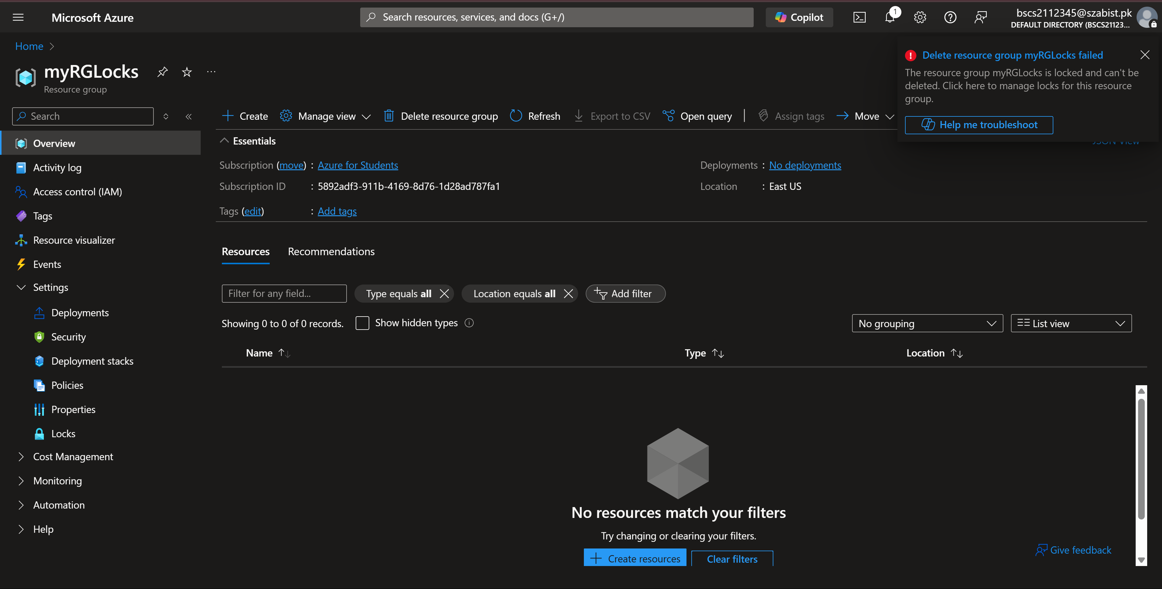

Task – 2: Test deleting a member of the resource group
Step 1: Locks on resource groups not only protect the RG, rather all it’s members are also protected under the same lock. To verify that I’ve filled in the basic details to create a storage account under the resource group “myRGLocks”.
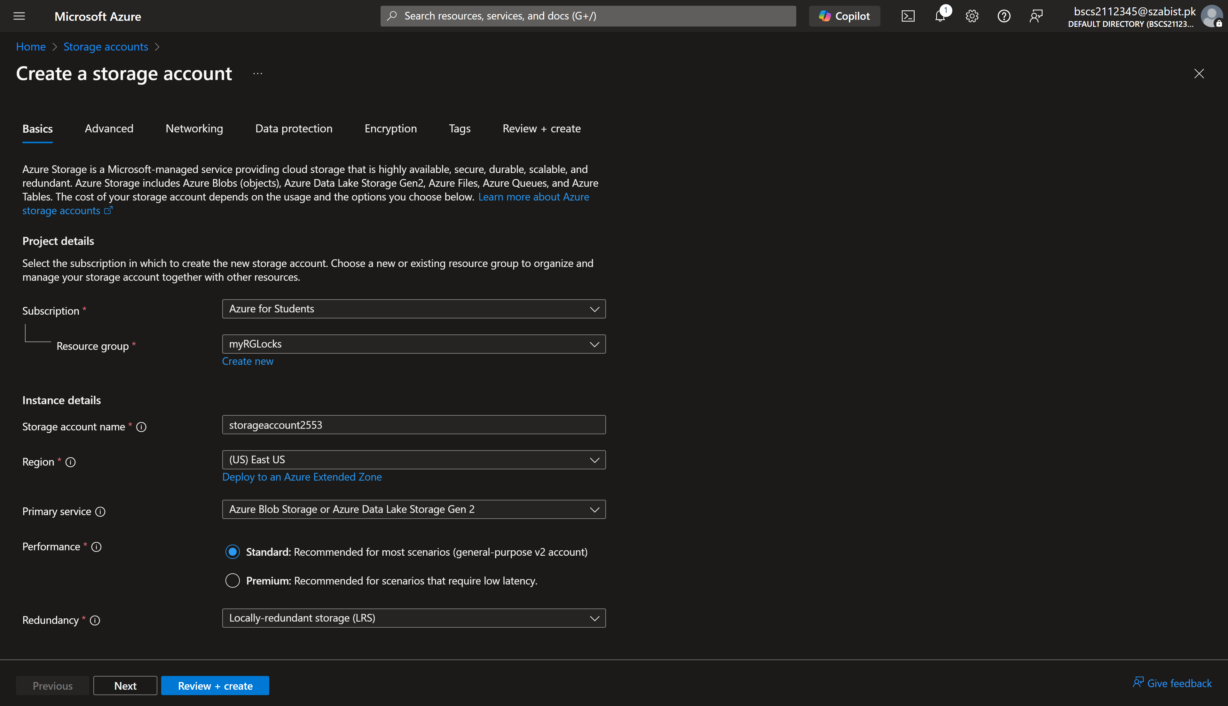
Step 2: After finalizing the configurations and all validations have passed, I’ve pressed create for the storage account to be deployed.
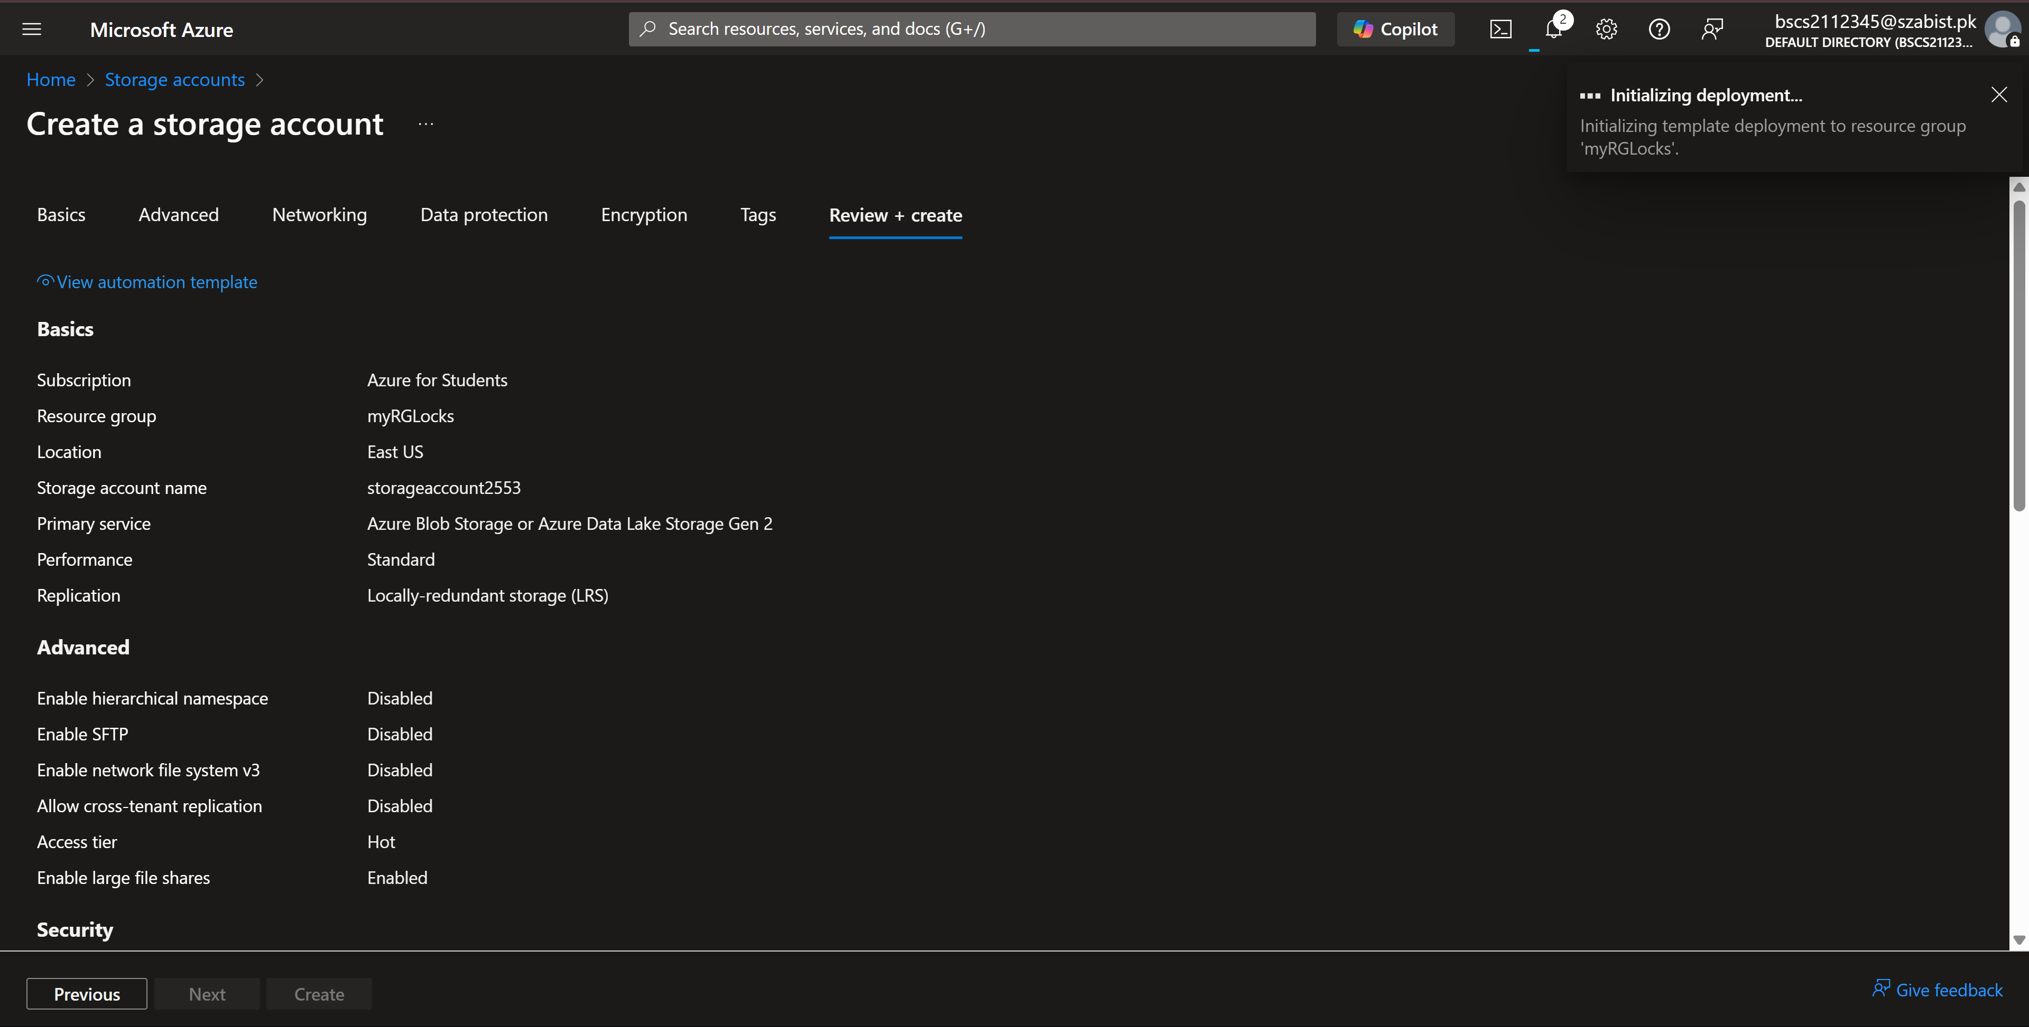
Step 3: Once the resource is created and I try to delete it, I am again prompted by azure that this resource or it’s parent has a lock which prevents it from being deleted.
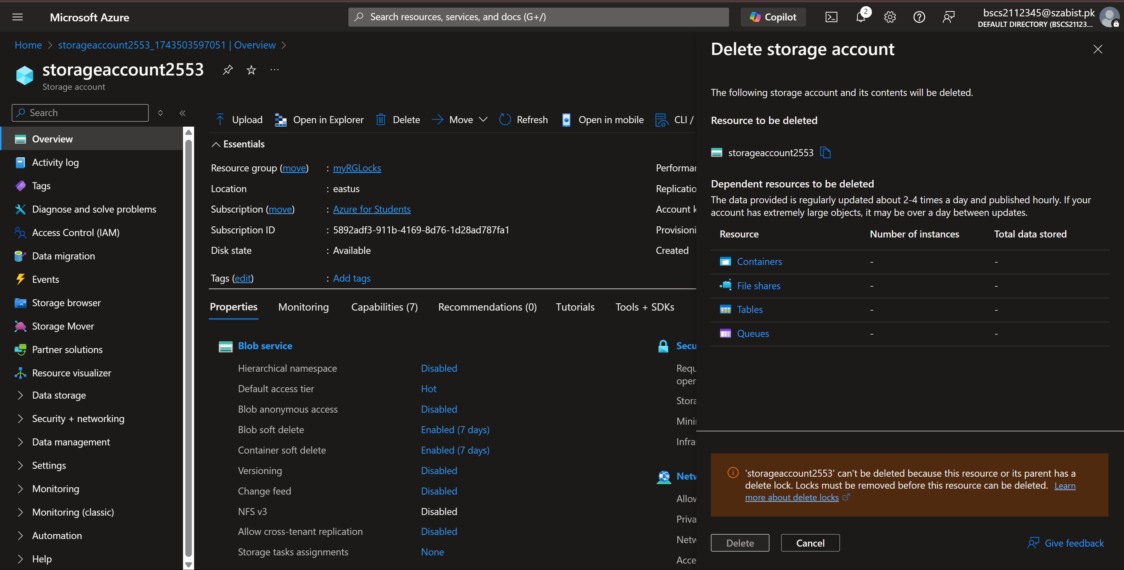

Task – 3: Remove the resource lock
Step 1: To verify that this lock is responsible for the prevention, I’ve deleted the lock to try deleting the resource now.
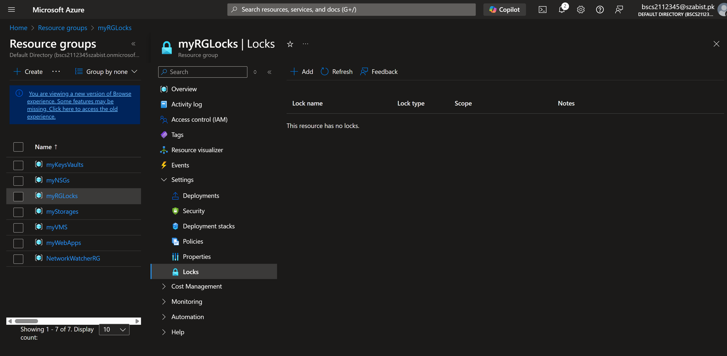

Step 2: After removing the lock, I again came to the resource and clicked delete and after a few seconds, the notification can be read as “Successfully deleted storage account”.
